 **CS-LAB # 03**

**Submitted by:**

Maaz Habib

**Registration No.:**

20PWCSE1952

**Section:**

C

Submitted to:

**Engr. Muniba Ashfaq**

31/JAN/2024

**Department of Computer Systems Engineering**

**University of Engineering and Technology, Peshawar**

**Task 01:**

**Code:**

t = 0:0.1:10;

Y0 = [0 1 1];

[T, Y] = ode23("diff_func", t, Y0);

plot(T,Y)

**Diff Function:**

function dy = diff_func(t, y)

dy = zeros(3,1);

dy(1) = y(2)*y(3);

dy(2) = -1*y(1)*y(3);

dy(3) = -0.51*y(1)*y(2);

**Output:**

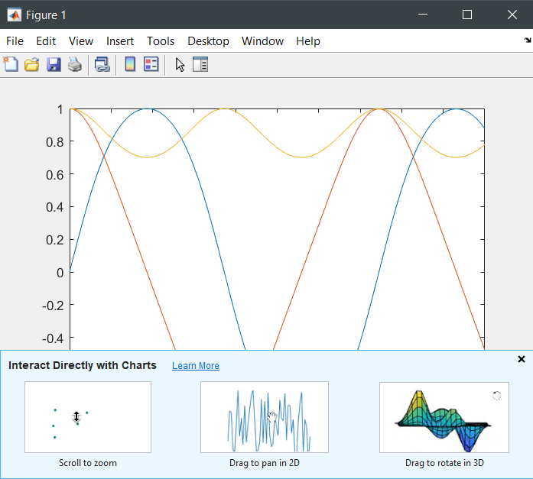

**Task 02:**

t = 0:0.1:10;

Y0 = [0 1];

[T, Y] = ode23("diff_func2", t, Y0)

plot(T,Y)

**Diff Function:**

function dy = diff_func2(t, y)

dy = zeros(2,1);

dy(1) = y(2);

dy(2) = -1*y(1)*y(1)*y(2) + y(2) - y(1);

**Output:**

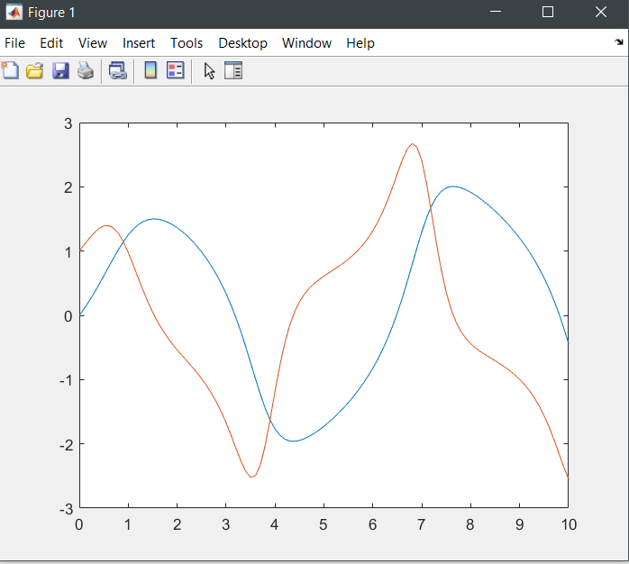

**Task 03:**

t = 0:1:10;

Y0 = [0 4 2 1 1];

[T, Y] = ode45('diff_func3', t, Y0);

plot(T,Y)

**Diff Function :**

function dy = diff_func3(t, y)

dy = zeros(5,1);

dy(1) = y(2);

dy(2) = y(3);

dy(3) = y(4);

dy(4) = y(5);

dy(5) = -1*y(5)*y(4) + 2*y(3)*y(2) -1*y(1);

**Output:**

